Add Segments to Existing Trip

To avoid multiple itineraries (and reservation fees) for a single trip, the Concur user can book all segments within the same itinerary. The user can add car or hotel segments to an existing reservation/itinerary at a later time.

From the Travel Home Screen, under Upcoming Trips, the Concur User will select the desired trip they would like to add a segment to:

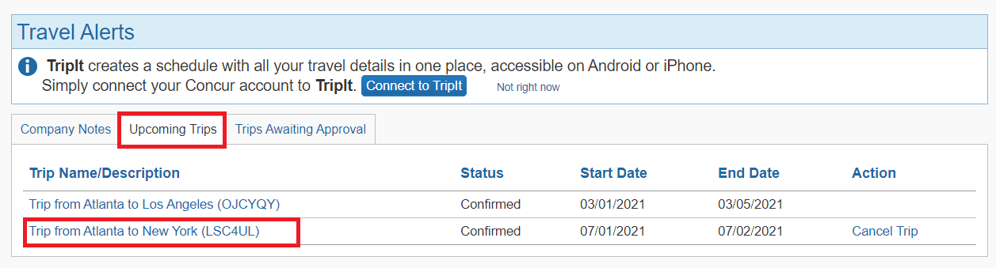

When the Concur User selects the desired trip they would like to modify, they will be redirected to the Trip Overview page of the reservation:

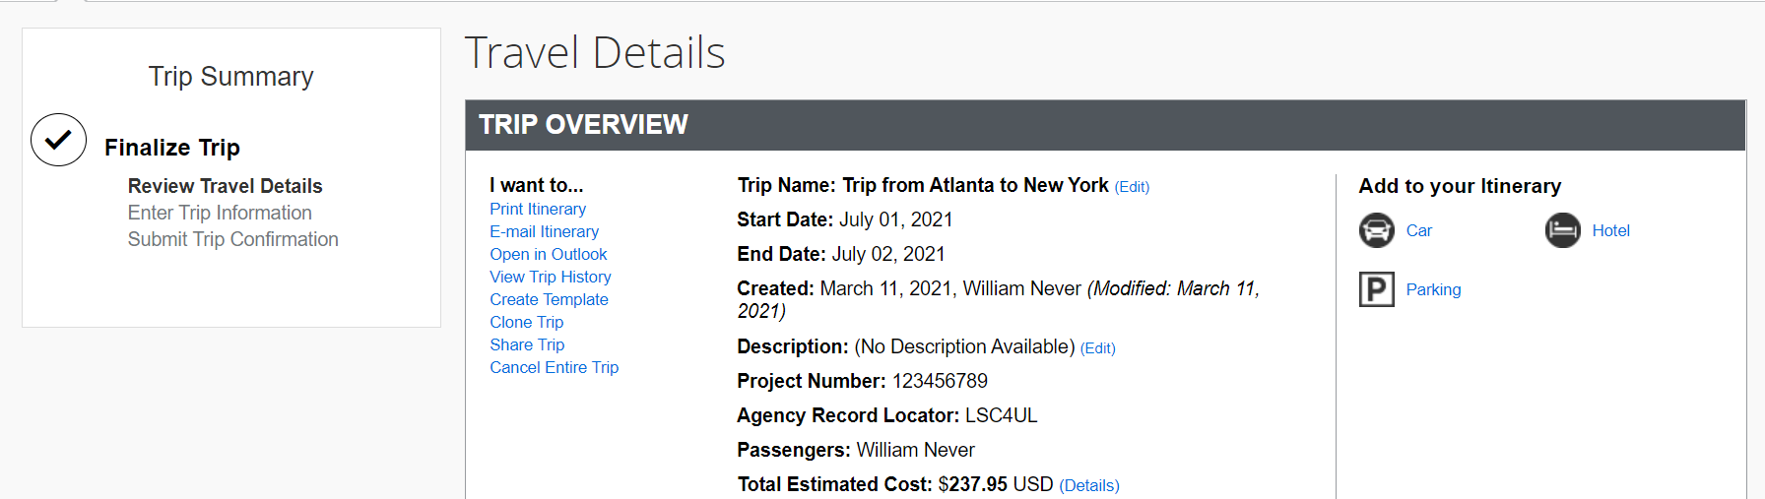

To update, you can click on the necessary icon on the right side of the Trip Overview Page. You also have the option to cancel by clicking on the “Cancel Entire Trip” tab located on the left hand side of the Trip Overview:

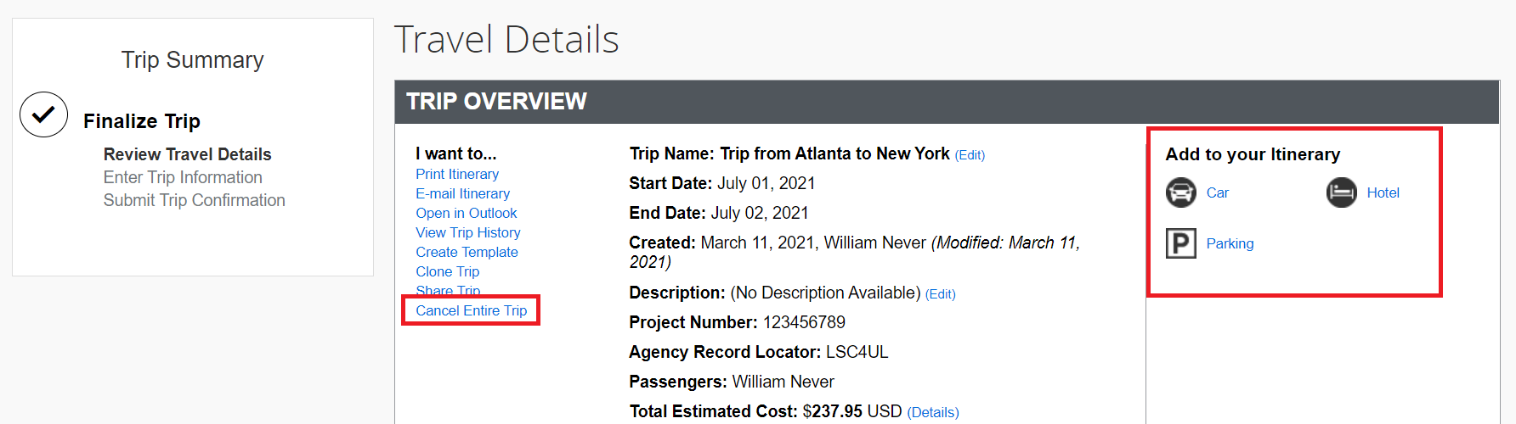

Choose the destination you require for the car or hotel portion of your trip and select Search

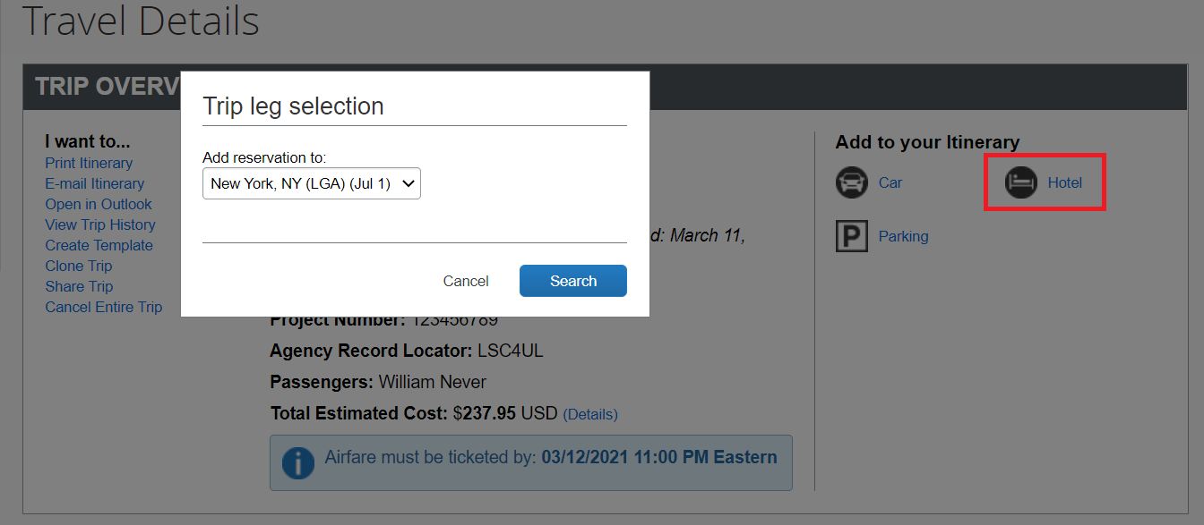

Your travel dates and city will auto populate based on your reservation details:

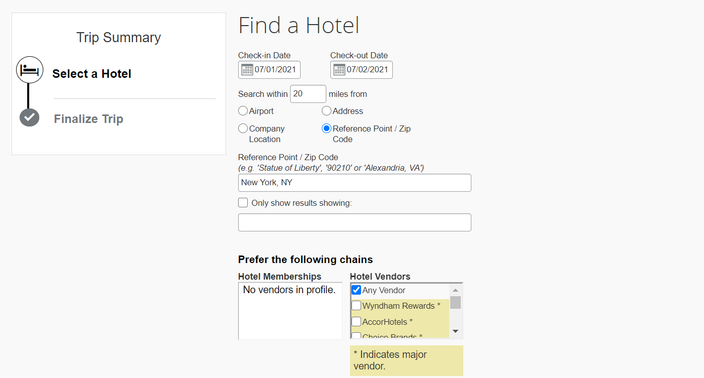
The search results will be displayed and you can make your necessary selection by clicking the Select Tab. Any preferred vendors will be notated in the search results:

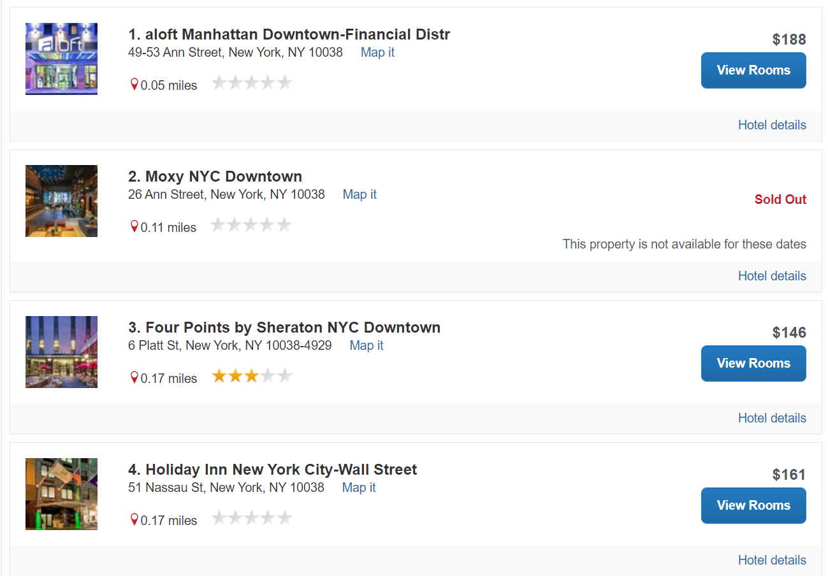

Select “View Rooms” to view the available room types at the desired property:
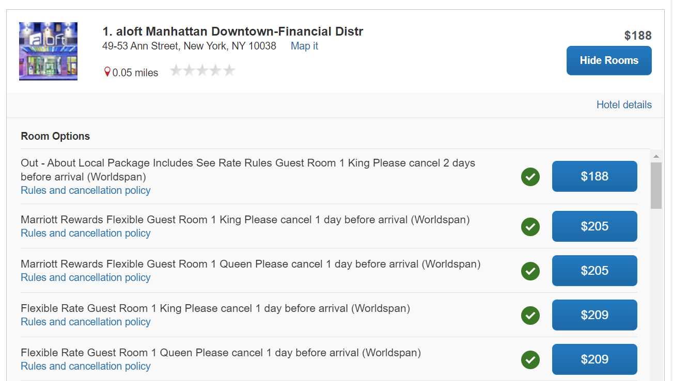

Select your desired rate and proceed with the booking process:

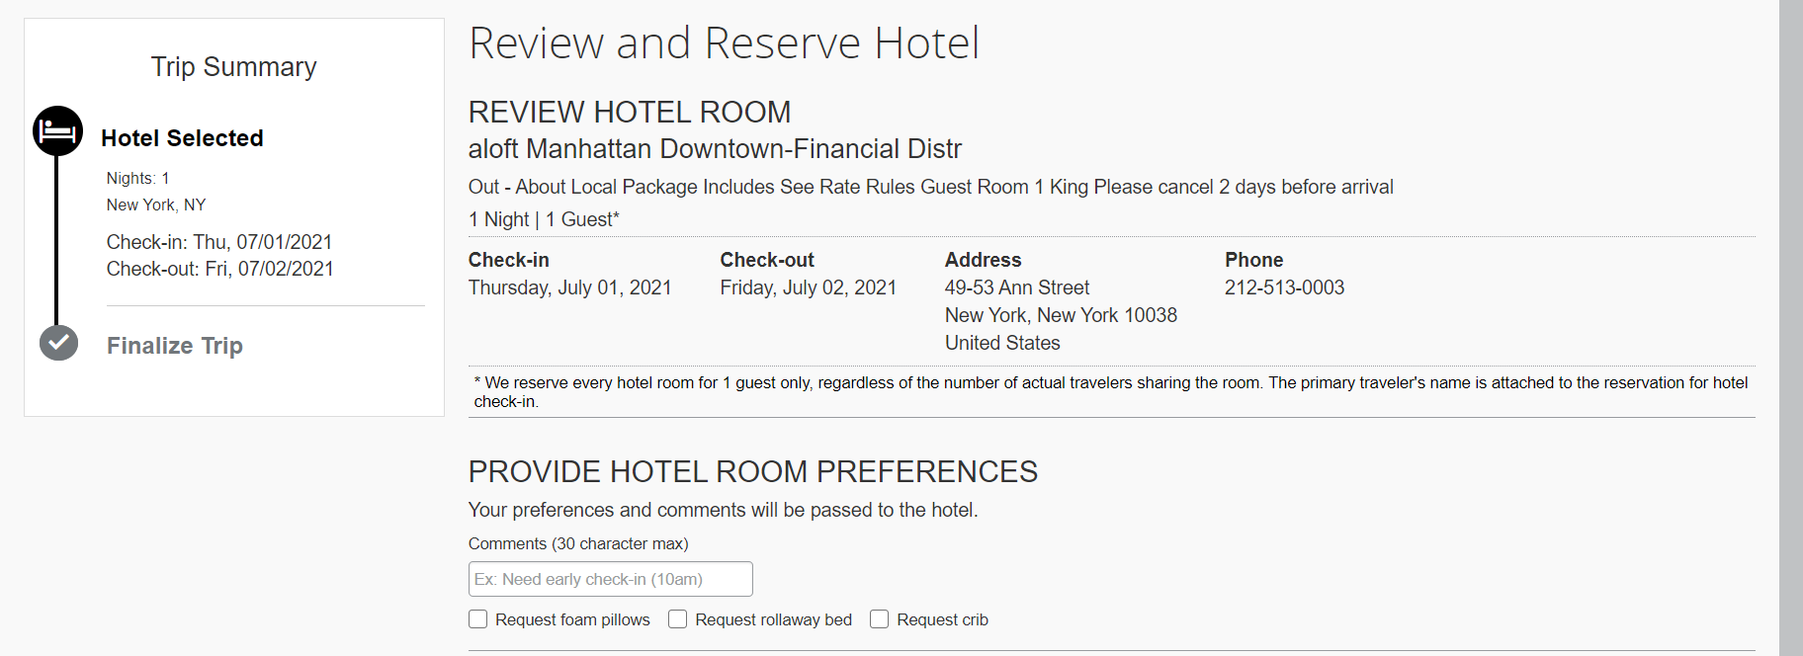

Be sure to read through the hotel’s cancellation policy and acknowledge that you have reviewed. Proceed by selecting “Reserve Hotel and Continue”:

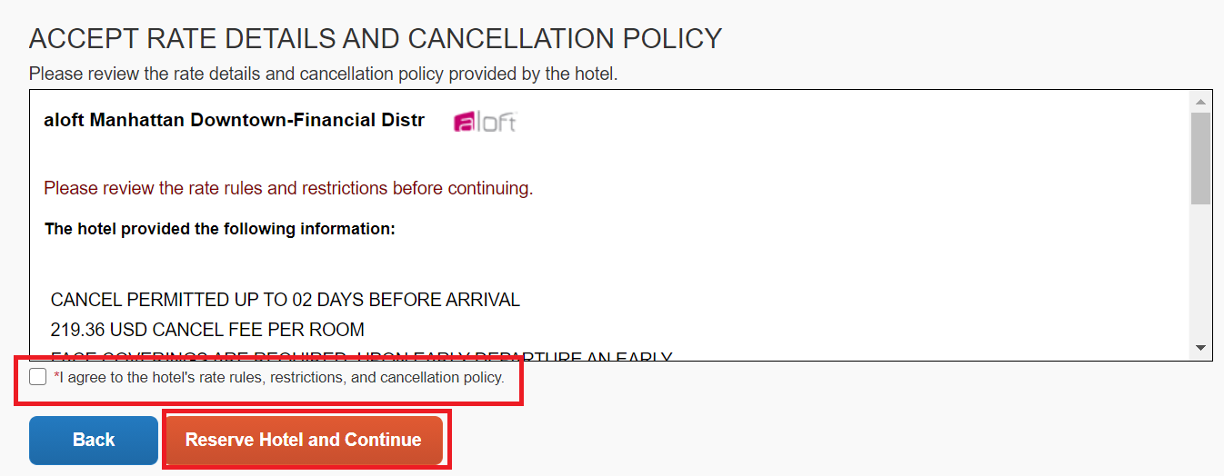

Continue through the prompts until you have reached the Finished page:

