Southwest Ticket Credits

Southwest Airlines Ticket credits are obtained from previously canceled reservations with Southwest Airlines. Note the following:

• Applying a credit is only available for sites accessing content solely from the Southwest Direct Connect
• Up to two credits may be applied to a new itinerary.
• The full name on the credit(s) must match the user's name for which the credit is being applied (first, middle, and last).
• Guest travel cancellations that result in a credit are added in the name of the person who made the guest travel booking

On the Review and Reserve page, the user selects the desired credit card and may also be able to use a ticket credit.

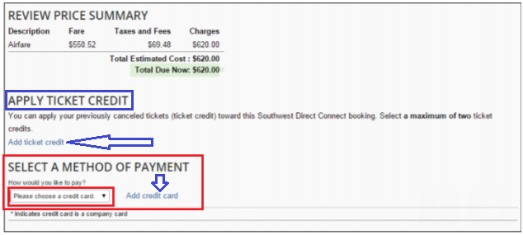

Users can add a credit that was obtained offline by clicking the Add ticket credit link: This will be necessary to import and apply a credit for a booking ticketed or cancelled outside of Concur Travel.
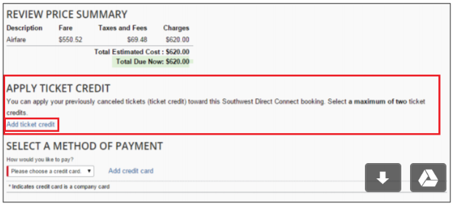

Only the Southwest Record Locator field is required, however, completing the Cancel Date and Ticket Amount fields is recommended when adding a ticket.
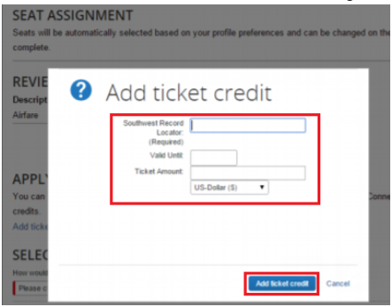

**Name Match**
If the name in the Concur Travel profile does not match the full name (first, middle, and last) of the credit on file, then Southwest does not apply the credit.
- The reservation is not stopped because of a name mismatch and no error message displays. This will allow the user to complete the booking regardless of whether the credit is applicable.
The Southwest allows a maximum of two ticket credits as form of payment per reservation.
- If a user selects more than two ticket credits, Concur Travel provides an error message for the user.
Application of Credit
The itinerary shown to the user displays the actual ticket price, not the fare after the credit is applied. The fare stored is also the face value of the ticket and not the add/collect amount.
- Once the exchange is processed, the ticket number and the ticket credits used as "form of payment" appear. When a user applies an existing credit, Concur Travel does not know the Southwest ticket number, only the confirmation number.
