Unfinished Reservations
- An Orphaned/Abandoned Trip occurs when the reservation is not fully completed after the Concur user selects the “Reserve” button in Concur.
- The Concur user will know if their reservation has been completed once they reach the Finished page in Concur:

- The Concur user may withhold completing the reservation, however, the user must return to the pending reservation within 4 hours to complete the booking. If the user fails to finish the reservation within those 4 hours, Concur will send out an Unfinished Trip warning email (including the Trip Overview) advising of the unfinished reservation (shown below)

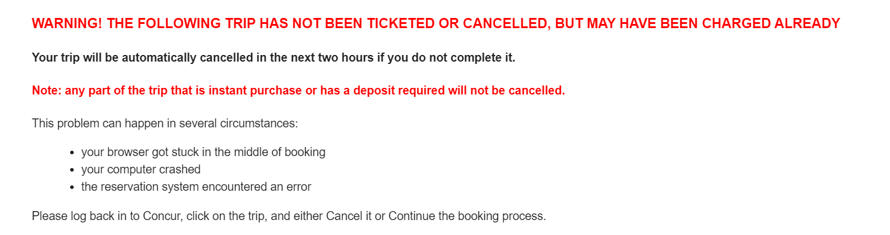

- Concur advises the reservation has not been Ticketed or Cancelled but may have been purchased (via instant purchase carriers/vendors).
- Concur advises to complete the unfinished trip or it will be cancelled within 2 hours.
- Concur advises to log back in to your site, select the unfinished trip and either select Cancel or Complete the booking process to purchase your ticket.
- When the Concur user logs back in to Concur, they will be presented with a warning notification of the unfinished trip:

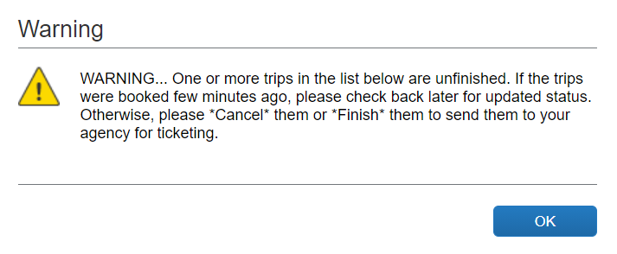
- Once the Concur user acknowledges the prompt, the user will then see the notification “Trip in Progress – Unfinished Reservation” in both the Travel Alerts and Upcoming Trips sections on the Travel home screen.
- Clicking on the trip description in either section will take the user back into the reservation to complete the booking or they can select “Cancel Trip”
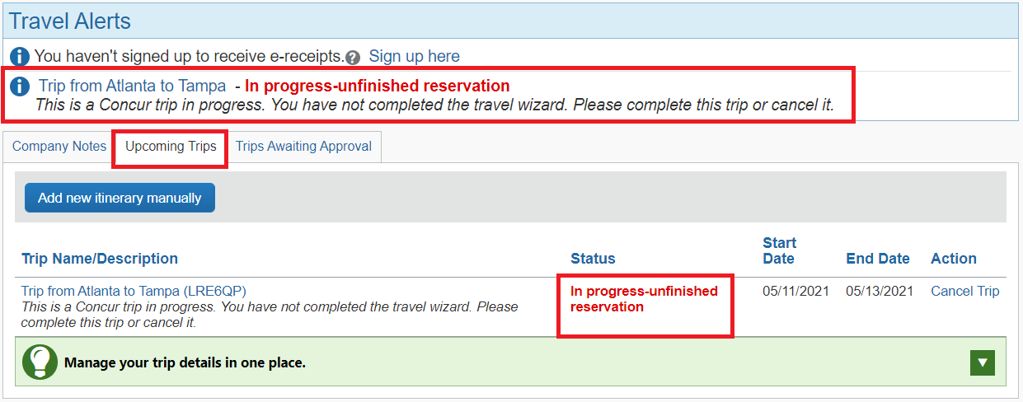
- If no action is taken, the Concur Travel auto-cancellation process engages, and the user is sent a cancellation notification via email:
- The entire process will take approximately 6 hours from the creation of the reservation.

Please note* Creating a new reservation for the same itinerary as an existing unfinished reservation may be considered an illegal booking infraction which could result in additional imposed airline fees.

